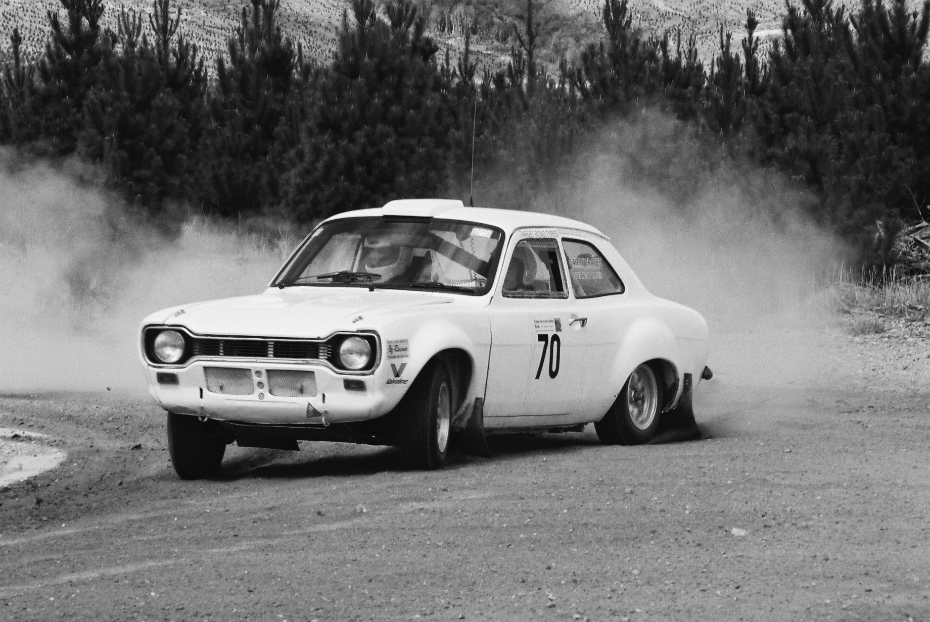


A Motorsport NZ affiliated club
www.classicrally.org.nz
Secretary@classicrally.org.nz

Taupo

www.classicrally.org.nz

Club Officer Holders for 2025

President: - Bernie Keith 027 889 8880
President@classicrally.org.nz

Secretary: - Alistair Steele 0274 343 500
Secretary@classicrally.org.nz

Treasurer: - Diana Barnes 07 3773237
Diana@twindizzy.com

Event Coordinator: - Alistair Steele 0274 343 500 alistair.steele48@gmail.com

Committee members: - Bevan Wilson 021 0820 7395

(Gravel events): - Martin Treadwell 027 311 7341

Andrew Treseder 027 464 0202

Colin Gibson 021 267 9034

Alan Barnes 027 443 3407

Malcolm Laycock 022 340 1543

No calls after 9.00pm please

